Ministry of Higher Education
University of Baghdad
Al- Khwarizmi College of Engineering
Information and Communication Engineering Department

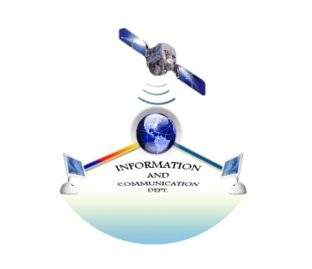

2017- 2018

1-Information & Communication Engineering Department: A Brief

The department of Information and Communications engineering was established in the beginning of the academic year 1997-1998 and joined to Al- Khwarizmi College of engineering in t h e academic year 2002-2003. The study period is four years, during which the students study various topics in information and communication engineering.
These topics cover a variety of subjects in communication and information engineering, such as the software and hardware of computer networks and how they can be linked together through the communication systems that used plain or secure channels. After completing the courses successfully, the students will be awarded a bachelor's degree in information and communication engineering.
- Vision
Our vision is to graduate students that able to efficiently tackle problems in their field by providing them with up to date theoretical and practical approaches related to the information and communication engineering.
- Mission
The aim of the department is devoted to teach information and communication engineering through:
1. Developing and providing students with modern techniques.
2. Creating a new generation of engineers that professionally able to update the IT and communications infrastructures.
3. Providing services to the community by solving issues that facing the industry sectors.
4- Goals:
Developing and improving the teaching and the research potential of the faculty members in order to be able to graduate an engineer that able to meet the local and global industrial demands.

5-Academic staff:

ت |  | اسم التدريسي | الاختصاص العام | الاختصاص الدقيق
1 |  | د.لواء فيصل عبد الامير | هندسة كهربائية | هندسة اتصالات ضوئية/مايكروويف
2 |  | د. سها محمد هادي | علوم حاسبات | نقل المعلومات الكترونيا"
3 |  | د. امير حسين مراد نادر | هندسة حاسبات | تمييز انماط
4 |  | د.خليفة عبود سالم | هندسة كهرباء | اتصالات
 | 5 | د. عمر يوسف شعبان | الكترونيك واتصالات | أتصالات ضوئية
6 |  | د. عمر علي عذاب | هندسة كهربائية | الكترونيك واتصالات
7 |  | د. احمد ستار هادي | هندسة كهرباء | هندسة كهرباء والكترونيك
8 |  | د.علي حسين حمد | هندسة سيطرة وحاسبات | هندسة سيطرة وحاسبات
9 |  | د. فاطمة بهجت ابراهيم | علوم حاسبات | علوم حاسبات
10 |  | د. ياسر احمد عبد الله | هندسة معلومات | اتصالات لاسلكية
11 |  | هبة محمد فاضل | هندسة حاسبات | هندسة حاسبات
12 |  | منى مصطفى حمادي | هندسة سيطرة ونظم | هندسة حاسبات
13 |  | سليم موله محمد | هندسة كهرباء | الكترونيك طائرات
14 |  | شاكر علي جابر | هندسة سيطرة ونظم | الألكترونيات الجوية
15 |  | زينة عباس عبد | الالكترونية واتصالات | ليزر
16 |  | سجى مجيد محمد | علوم حاسبات | علوم حاسبات
17 |  | حارث فخري طاهر | هندسة حاسبات | هندسة حاسبات
18 |  | احمد كاظم حسن فرج | هندسة معلومات | الكترونيك واتصالات
19 |  | أحمد محمد صاحب | هندسة معلومات | هندسة شبكات وتقنية شبكات دولية
20 |  | عادل فاضل مشتت | كهربائية والكترونية | هندسة الأتصالات والوسائط
21 |  | هبة محمد فاضل | هندسة حاسبات | هندسة حاسبات
22 |  | احمد عماد عزيز | هندسة حاسبات | هندسة حاسبات
23 |  | علي صلاح مهدي | معلومات واتصالات | واتصالات
24 |  | زينة اسامة داود | الكترونيك واتصالات | الكترونيك واتصالات
25 |  | طارق عماد علي | الكترونيك واتصالات | الكترونيك واتصالات
26 |  | شاكر كباشي خلف | قانون | قانون أداري

6- Engineers:

Names | Occupation | Degree
Ahmed Ameer | Engineer | B.Sc/ Electrical Eng.
Shaema Dhiaa Aldeen | Assistant Engineer | B.Sc./ Electronics Eng.
Noor Kadorii | Assistant Engineer | B.Sc./ Ccomputer Eng.
Alyaa Mohammed | Assistant Engineer | B.Sc./ Computer Eng

7- Administration staff:

Names | Occupation | Position
Abeer Zuheir Ali | Observer | Secretary
Nargs Mohammed Ali | Observer | Secretary

8- Scientific Laboratories:
As a complement of the Academy section structure it contains three quality laboratories, namely:
- The Networking laboratory
Which includes a group of computers connected through a server. The laboratory materials will specialized and including the following fields:

- Engineering drawing by using computer lab
- Computer Networks
- Programming lab
- Drawing and design by computer
- Design of databases
- Object oriented programming
- Analysis and design of information systems
- Operating Systems • Microprocessor
- Data structures and algorithms
- Network management lab

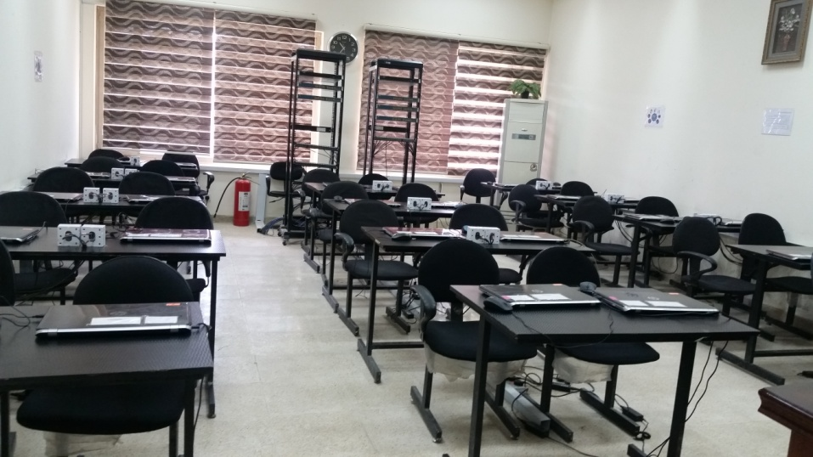

- Electronic and communications laboratory

It include a variety of modren equipments interfaced to PCs, those eqipmnets serve the following subjects:
- optical networks lab
- Electrical Engineering
- Communications
- Electronic
- Information

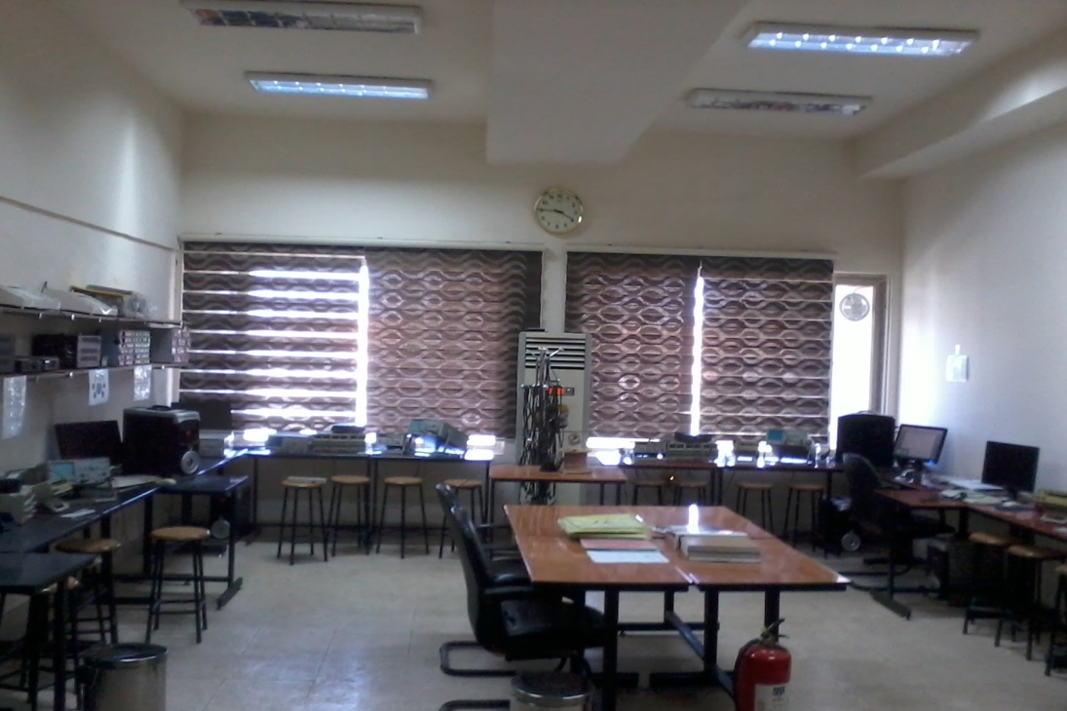

- The Programs Labs:
This lab has been founded as a first lab equipped with laptops to serve the subjects related to the new branch like:
- Image Processing lab.
- Multimedia Lab.
- Computer Graphics Lab.
- Multimedia Systems Lab.

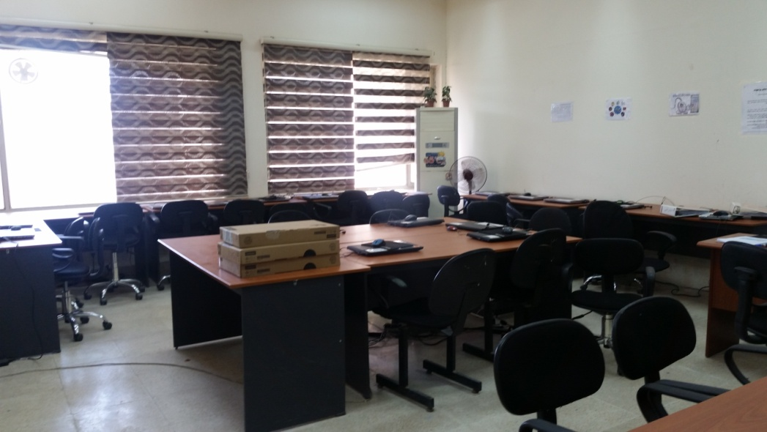

9- Under graduated curriculum Units:

First stage - 1st Semester
Code | SUBJECT | Teaching Scheme |  |  | Credits
 |  | L | T | P
ICE101 | Mathematics I | 2 | 2 | 0 | 2
ICE102 | Engineering Drawing | 1 | 0 | 2 | 2
ICE103 | Physics of Electronic Devices | 3 | 0 | 0 | 3
ICE104 | Electric Circuit Theory | 2 | 1 | 3 | 3
ICE105 | Computer Programming | 2 | 1 | 3 | 3
ICE106 | Human Rights | 1 | 0 | 0 | 1
Total |  | 11 | 4 | 8 | 14
 |  | 23

First stage – 2nd Semester
Code | SUBJECT | Teaching Scheme |  |  | Credits
 |  | L | T | P
ICE107 | Mathematics II | 2 | 1 | 0 | 2
ICE108 | Structured Programming | 2 | 1 | 3 | 3
ICE109 | Electronic Devices & Circuit | 2 | 1 | 2 | 3
ICE110 | Digital Electronics | 2 | 1 | 2 | 3
ICE111 | Data Analysis and Visualization  (MATLAB) | 0 | 0 | 3 | 1
ICE112 | Democracy | 1 | 0 | 0 | 1
ICE113 | Academic English | 2 | 0 | 0 | 2
Total |  | 11 | 4 | 10 | 15
 |  | 25

Curriculum Syllabus:

First stage - 1st Semester

Mathematics I:
This course contributes primarily to the students’ knowledge for working professionally in the area of science of mathematics. Students should be able to apply knowledge of mathematics, science and engineering. Students will be introduced to calculus, series, differential equations, matrix, complex numbers and vectors.

Computer Drawing:
Introduction, computer & engineering drawing, 2D drawing-Basic elements (line, arc, …etc.), viewing & editing drawing, setting element properties (color, line, type, layer, ...etc.), enhancing engineering drawing (text, and dimensions), use advanced drawing technology in engineering design (poly lines and blocks) in engineering design, engineering drawing technology (paper space and plotting)

Computer programming:
This course teaches the basics of computer programming.

Electric Circuits:
To acquaint students with the basic concepts and properties of electrical circuits and networks; and To prepare students for follow-up courses in the Circuits area of the Electrical Engineering program.

Physics:
To acquaint students with the basic concepts and properties of semiconductor devices; and their operation.

Technical English language:
Revision of grammatical structures with emphases on technical usage, augmentation of technical vocabulary, dictionaries. Precise writing, descriptive and reflective paragraphs writing, Practice in presentation of passage original idea in a summary form, writing original compositions on themes connected with passages. Technical writing, clear and accurate writing on themes of common and technical English , theme discussion,

Human Rights and General Freedoms:

- The historical fundamental base of the human right and its development in our nation
- Human right in old age
- Human right links to low and out border educational
- General view of freedom
- Historical development of freedom
- Designation of the freedom
- Classification of the freedom

First stage – 2nd Semester

Data analysis and visualization:

The description of this academic mat lab program provides a brief summary of the main characteristics of the program and the learning outcomes of the students. And accompanied by a description of each course within the program.

Digital Electronics

This course contributes primarily to the students’ knowledge for working professionally in the area of logic design. Students should be able to apply knowledge of science and engineering, as well as the techniques, skills, and modern engineering tools to analyse, design and optimize logic circuits.

Electronic Devices

To acquaint students with the basic operation and properties of Electronic devices; and their operation.

English

To encourage students to actively involved in participative learning of English and to help them acquire Communication Skills

Mathematics:
Students will be introduced to mathematics, their principle of analysis and their applications.

physics
To acquaint students with the basic concepts and properties of semiconductor devices; and their operation.

Second stage:

Second Stage - 1st Semester
code | Subject | Teaching Scheme |  |  | Credits
 |  | L | T | P
ICE201 | Signal &Systems I | 3 | 0 | 0 | 3
ICE202 | Probability and Random Processes | 2 | 1 | 0 | 2
ICE203 | Electromagnetic Fields & Propagation | 2 | 1 | 0 | 2
ICE204 | Electronic Systems | 2 | 1 | 2 | 3
ICE205 | Object Oriented Programming | 2 | 1 | 2 | 3
ICE206 | Microprocessor | 2 | 1 | 2 | 3
ICE207 | Arabic Language | 1 | 0 | 0 | 1
ICE208 | Academic English | 2 | 0 | 0 | 2
Total |  | 16 | 5 | 6 | 19
 |  | 27

Second Stage - 2nd Semester
code | Subject | Teaching Scheme |  |  | Credits
 |  | L | T | P
ICE209 | Signal &Systems II | 3 | 0 | 0 | 3
ICE210 | Analogue Communication | 2 | 1 | 2 | 3
ICE211 | Antenna Theory | 2 | 1 | 0 | 2
ICE212 | Web Design & Development | 2 | 0 | 3 | 3
ICE213 | Programming Paradigms | 2 | 1 | 3 | 3
ICE214 | Digital System Design | 2 | 1 | 2 | 3
Total |  | 13 | 4 | 10 | 17
 |  | 27

Curriculum Syllabus:

Signal &Systems I:
Signal types; System properties; Differential and Difference Equations; Convolution; Fourier Series; Parseival’s Theorem; Fourier Transform; Signal Transmission Through Linear System; Fourier Analysis of Discrete-Time Signals and Systems; Filtering; Continuous-time modulation.
Probability and Random Processes:
After successfully completing the course, students should be able to do the following: Use statistical methodology and tools in the engineering problem-solving process. Compute and interpret descriptive statistics using numerical and graphical techniques.
Electromagnetic Fields & Propagation:
Fundamentals of Electromagnetic Analysis, Electrostatics, The Steady Magnetic Field, Maxwell’s Equations, Electromagnetic Waves, Pointing Vector and The Flow of Power, Guided Waves, Wave Guides, Fundamentals of Antennas and Antenna Parameters, Basic Antenna Types, Radiation and Radar Equation, Troposphere Propagation.

Electronic Systems:
To acquaint students with the basic concepts and properties of electronic systems; To prepare students for follow-up courses in the Electronic Circuits area of the communication Engineering program.

Object Oriented Programming:
This course provides in-depth coverage of object-oriented programming principles and techniques using C++. Topics include classes, overloading, data abstraction, information hiding, encapsulation, inheritance, polymorphism, file processing, templates, exceptions, container classes, and low-level language features. The course briefly covers the C++ implementation and object-oriented considerations for software design and reuse. The course also relates C++ to GUI, databases, and real-time programming.
Microprocessor:
understand the main components and working principals of the Intel microprocessor
program and debug in assembly language, understand the basic computer architecture, understand the memory organization and memory interfacing, perform input/output device programming in assembly, understand the hardware and software interrupts and their applications, understand the properties and interfacing of the parallel and serial ports

Arabic Language :
the technician Arabic language, the engineering Arabic word, the English word and its Arabic originality, the vocabulary, the grammar, type of sentences, the writing science, lecturing science.

Third stage:

Third Stage - 1st Semester
code | Subject | Teaching Scheme |  |  | Credits
 |  | L | T | P
ICE301 | Digital Signal Processing | 2 | 1 | 3 | 3
ICE302 | Digital Communication | 3 | 0 | 0 | 3
ICE303 | Information Theory | 3 | 0 | 0 | 3
ICE304 | Computer Networks | 2 | 1 | 3 | 3
ICE305 | Data Structure | 2 | 1 | 3 | 3
ICE306 | Computer Architecture | 3 | 0 | 0 | 3
ICE307 | Academic English | 2 | 0 | 0 | 2
Total |  | 17 | 3 | 9 | 20
 |  | 29

Third Stage - 2nd Semester
code | Subject | Teaching Scheme |  |  | Credits
 |  | L | T | P
ICE308 | Technical Assignment(mini Project) | 1 | 0 | 3 | 2
ICE309 | Digital Communication System | 3 | 0 | 2 | 4
ICE310 | Error Control Coding | 3 | 0 | 0 | 3
ICE311 | Network Protocols | 2 | 1 | 3 | 3
ICE312 | Computer Algorithms | 3 | 0 | 2 | 4
ICE313 | Data-Base Design | 2 | 0 | 3 | 3
Total |  | 14 | 1 | 13 | 19
 |  | 28

Curriculum Syllabus:

Third Stage - 1st Semester

Digital Signal Processing:
Combinational logic cct. With MSI & LSI and Function Implementation, PLA, PAL, ROM,… Synchronous Sequential logic cct., Asynchronous Sequential logic cct., Algorithmic state machines (ASM).

Digital Communications:
Signal Analysis and Representation Classification of signals and systems, Fourier series and F-T, Parse Val's power theorem, Raleigh’s energy theorem. Convolution theorem: (time convolution theorem, frequency convolution theorem, prepares of convolution, graphical interpretation), response of linear system, Sampling Theorem, Pulse Modulation, PAM, PDM, PCM, DPCM, ADPCM DM, ADM. Matched Filter. Digital modulation system: ASK, FSK, PSK, DPSK, demodulation, carrier recovery, M-ray PSK modulation, & M-ary FSK modulation, Traffic Theory. Spread Spectrum System.

Information theory:
Communication Systems & Information Theory, A Measure of Information, Communication Channels & Capacity, Source Coding, Error Control Coding.

Computer Networks:
Introduction to DB Processing – DB Development (DB, DBMS, Creating the DB) – The Entity Relation Model (DB elements, Network, Hierarchical, Relational models) – DB design (Relational Model DB, Normalization) – DB design using ERD (Relational Algebra, SQL) – db Application using Internet Technology (Network environment, 3 Tier Architecture, DB Web Server).

Data Structure:
Definition: Data Structures and Algorithms, Data Types and Abstract Data Types (ADT)(with C++ for Lab), Fundamentals of Data Structure (Static Structure, Dynamic Structure, Searching and Storing Algorithms, Files and Data Base).

Computer Architecture:
Review of Digital Circuits, Register transfer and Micro- Operation, Basic Computer Origination and Deign, Programming the Basic computer, Micro programmed control, The Central Processing unit.

Curriculum Syllabus:

Third Stage - 2nd Semester

Technical Assignment(mini Project):
The description of this academic practical course provides the essential skills required by the student for any project and the learning outcomes of the students accompanied by a description of each course within the program.

Digital Communication System
The course aim to gave the student the following subjects:
Signal transmission through linear system, distortion, Gaussian probability density function , Q-function , Detection of binary signals in AWGN. Probability of error for bandpass signals {ASK,PSK,FSK,QPSK } , coherent detection, synchronization methods, ISI, Eye diagram, ZF channel equalization, MCM & OFDM, Spread Spectrum Systems {DSSS & FHSS}.

Error Control Coding

Network Protocols

This course contributes primarily to the students’ knowledge for working professionally in the area of Computer Networks. Students should be able to apply knowledge of the techniques, skills, and modern engineering tools to analyse, design and implement different Computer Networks.

Computer Algorithms
Analyze the asymptotic performance of algorithms. Apply important algorithmic design paradigms and methods of analysis, Study different sorting, searching, graph and tree algorithms.

Data-Base Design
This course contributes primarily to the students’ knowledge for working professionally in the area of DataBase Design. Students should be able to apply knowledge of Business Rules, Analysis and DataBase Design techniques , as well as the software skills, and tools that are used in analyse and design of the DataBases.

Fourth Stage;

Fourth Stage - 1st Semester
code | Subject | Teaching Scheme |  |  | Credits
 |  | L | T | P
ICE401 | Internet Architecture | 3 | 0 | 0 | 3
ICE402 | Wireless Mobile Communication | 3 | 0 | 0 | 3
ICE403 | Networks Management | 2 | 1 | 3 | 3
ICE404 | Operating Systems | 2 | 0 | 3 | 3
ICE405 | Engineering Project | 1 | 0 | 3 | 2
ICE406 | Elective I | 3 | 0 | 0 | 3
ICE407 | Academic English | 2 | 0 | 0 | 2
Total |  | 16 | 1 | 9 | 19
 |  | 26

Fourth Stage - 2nd Semester
code | Subject | Teaching Scheme |  |  | Credits
 |  | L | T | P
ICE408 | Cryptography | 2 | 1 | 0 | 2
ICE409 | Optical Communication Networks and Systems | 3 | 0 | 3 | 4
ICE410 | Wireless Networking | 3 | 0 | 3 | 4
ICE411 | Information Systems Analysis | 3 | 0 | 0 | 3
ICE412 | Engineering Project | 1 | 0 | 3 | 2
ICE413 | Elective II | 3 | 0 | 0 | 3
Total |  | 15 | 1 | 9 | 18
 |  | 25

Curriculum Syllabus:

Fourth Stage - 1st Semester

Information System Analysis and Design:
Information system analysis and design concept (SAD, IT, Information system building blocks) system development life cycle phases (Planning, Analysis, Design, Implementation), system development methodology (what is methodologies, Structured design development, rapid application development, selecting the appropriate methodology), tools support system development (CASE tools, Microsoft project management), modeling system requirement, (data flow diagram, process flow diagram), system design strategies (elements, selecting strategies), system design tasks (DB design, user interface design, network design).

Satellite communications:
History of the satellite, applications of the satellite, types of satellite, orbit equation, block diagram satellite, and Sub satellite, received signal: calculate the power transmitted from the earth station to satellite, effective of rain, snow, ice, atmosphere, ionosphere, temperature, and the noise on the power signal, noise temp, noise figure, and system noise temperature, modulation, and multiplexing: FDM, TDM, CDM, Multi channel per carrier for analogue and digital transmission, Multiple accesses techniques, FDMA, TDMA, and CDMA. Digital Communication Process via Satellite: Types of coding, Decoding, and Calculate the code gain.

Computer Network:
Introduction and basic concepts, the OSI model, signals encoding, transmission of digital data and interfaces, transmission media, error detection and correction, data link layer controls and protocols, local area networks, data switching and routing, internetworking devices, transport layer and upper OSI layers, network performance , standard protocols and services.

Operating Systems:
Computer system overview, operating system overview, definition, processes management, CPU scheduling, process synchronization, memory management, file management, and network operating system.

Internet Architecture:
Networks essentials, internet services, IP addresses and sub netting, Ethernet frame format, IP header format, TCP & UDP header format, SLIP, PPP, ARP, DNS, bridges, routers and routing protocols, HTTP protocol, FTP protocol, DHCP, internet security, introduction to Web pages development.

Cryptography and Data Security:
Introduction, classical cipher systems, stream ciphers, block cipher, public key cryptography, practical security, introduction to computer viruses, information security and safeguarding, information hiding (watermarking, steganography).

Optical Communications:
Optical background, optical fiber communication system, optical fibers, optical sources, optical detectors, overall system, application, and case study.

Engineering Project
Application as a part of graduating requirement

Communications lab
Doing the experimental test

